**Low Energy Precision Application (LEPA) and Low Elevation Spray Application (LESA)**

**in the Pacific Northwest**

Troy Peters, Howard Neibing, and Richard Stroh

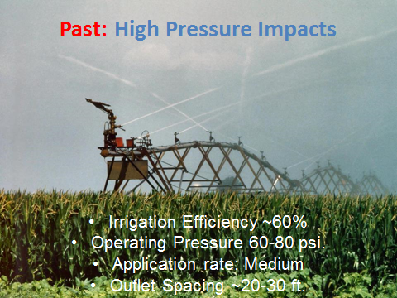

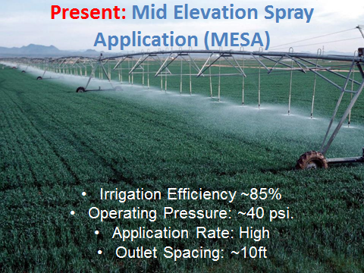

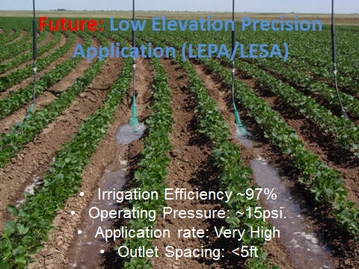

**Low Energy Precision Application (LEPA)** – Dribbles on.

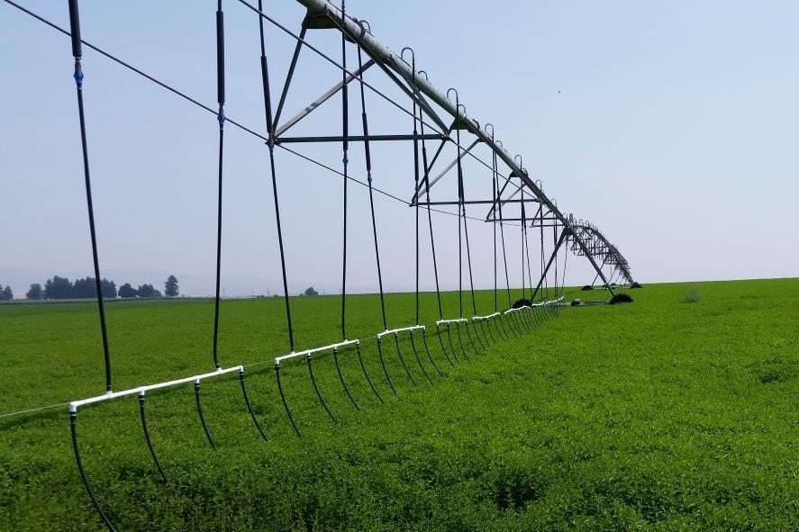

**Low Energy Spray Application (LESA)** – is sprayed on.

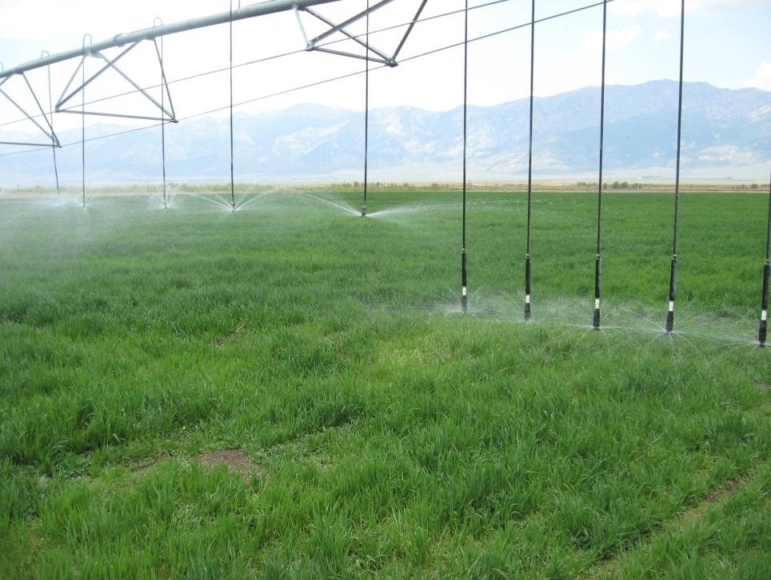

Additional hardware costs can be offset by the pumping power savings due to lower pumping pressure requirements and improved irrigation efficiency (less water is required).



LESA gives less time for water to infiltrate into the soil.

Therefore it may not be suitable to tight soils or steep slopes where infiltration and runoff can be an issue.

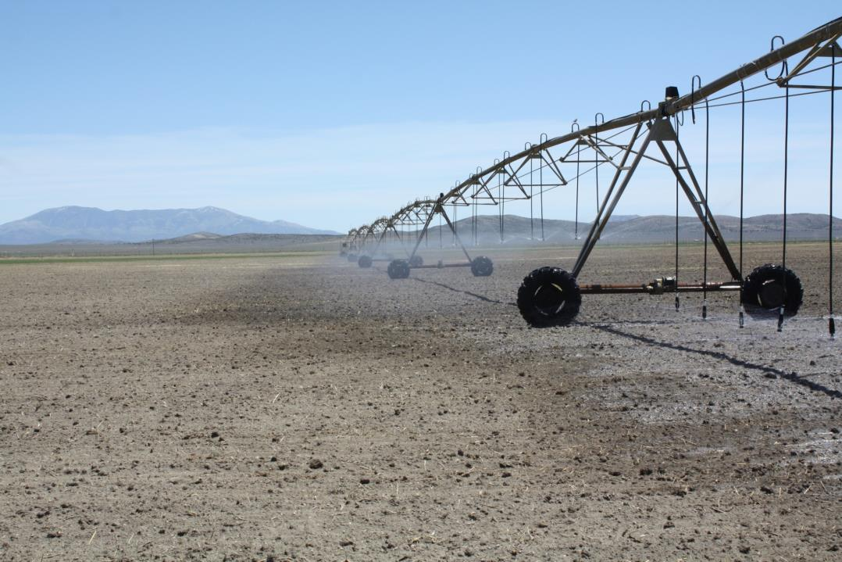

Double goosenecks and truss-rod hose slings can also decrease drop spacing & increase the number of drops. It also spreads the water out to increase infiltration.

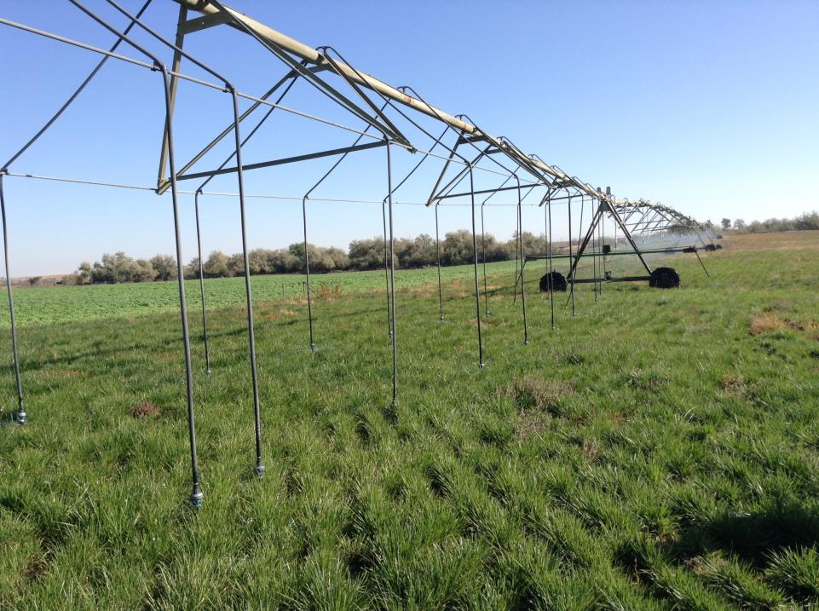

LESA worked well in corn. The narrow spacing eliminates typical uniformity issues on wider spacings due to the canopy disrupting the application pattern. It didn’t hang up too much in the canopy. No need to plant in a circle. 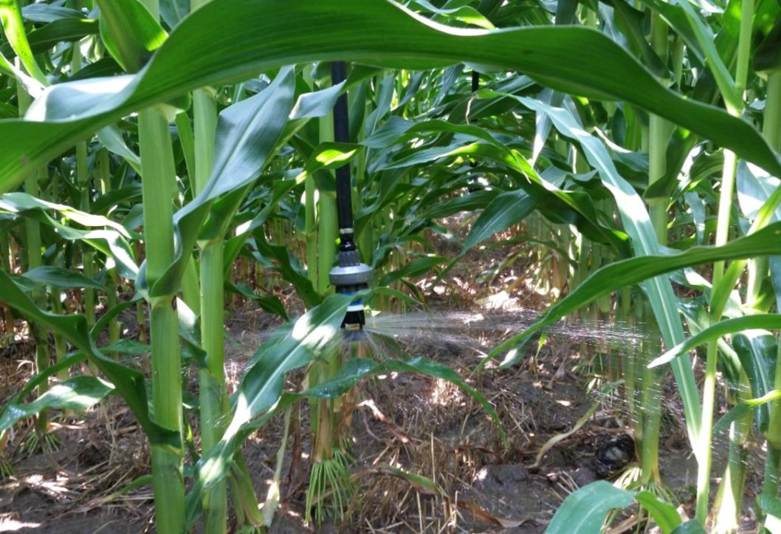

The sprinkler head can irrigate below the top of the canopy without problems. 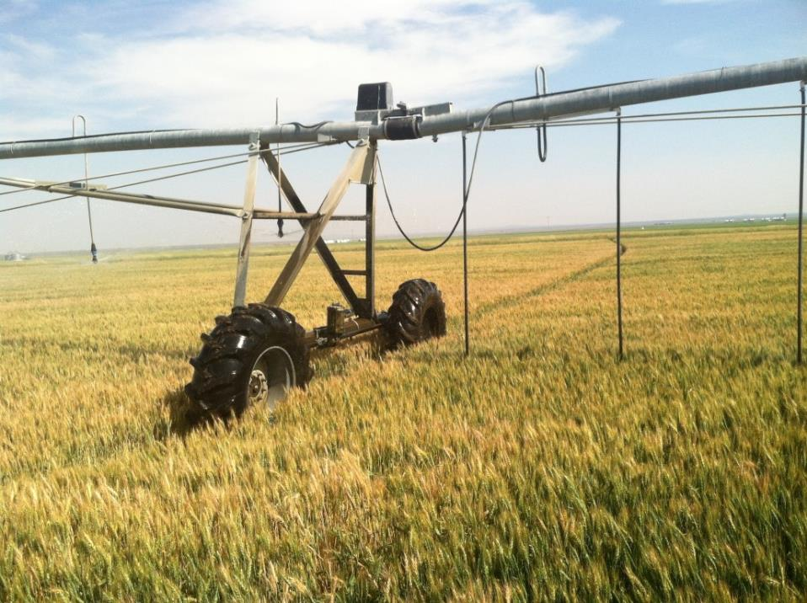

Sprinklers operating within the canopy. The heads stay dry. May decrease lodging, and increase irrigation application efficiency due to less water lost to evaporation from wet canopy.

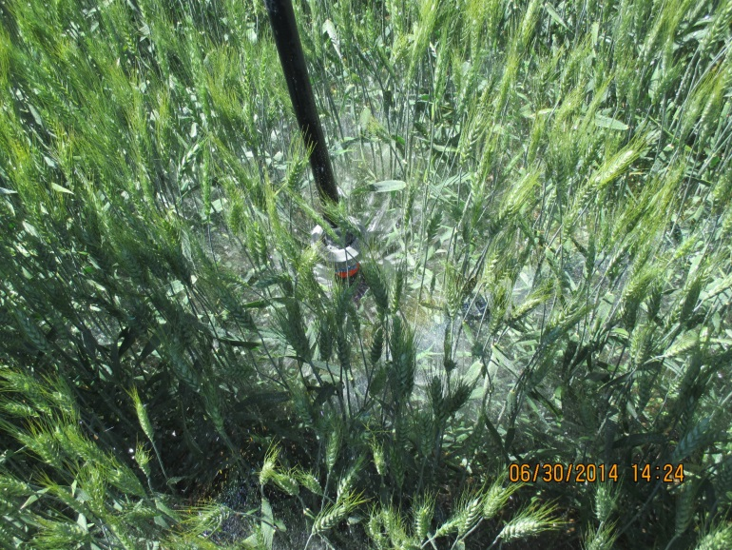

Chemigation plates can be used to spray water upwards to improve canopy wetting for chemigation.

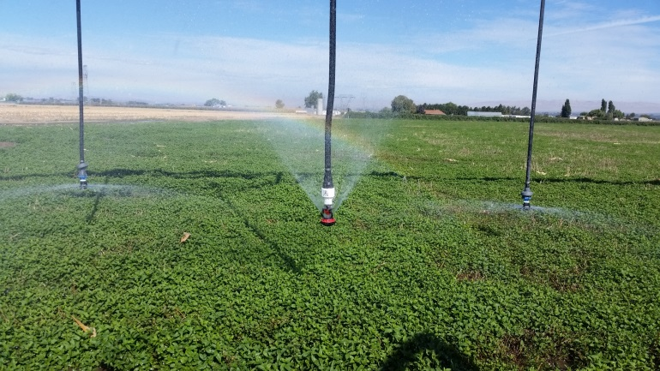

Catch can efficiency comparisons (10 replications) measured an average of 14.7% more water to the ground with LESA compared to MESA. Differences were statistically significant at the 0.05 level.

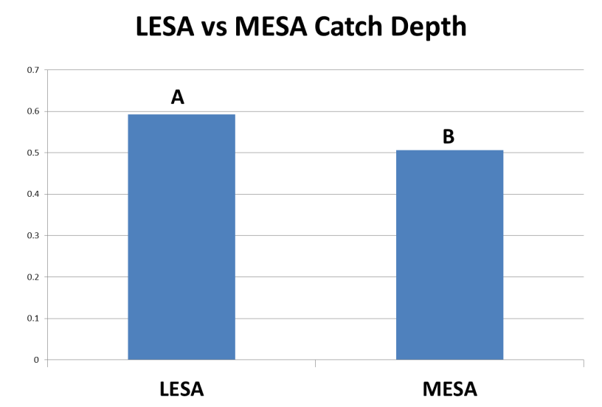

We can test your field to determine if LEPA/LESA will work for you. Please contact us (see below) if you are interested in having us come test your infiltration rates.

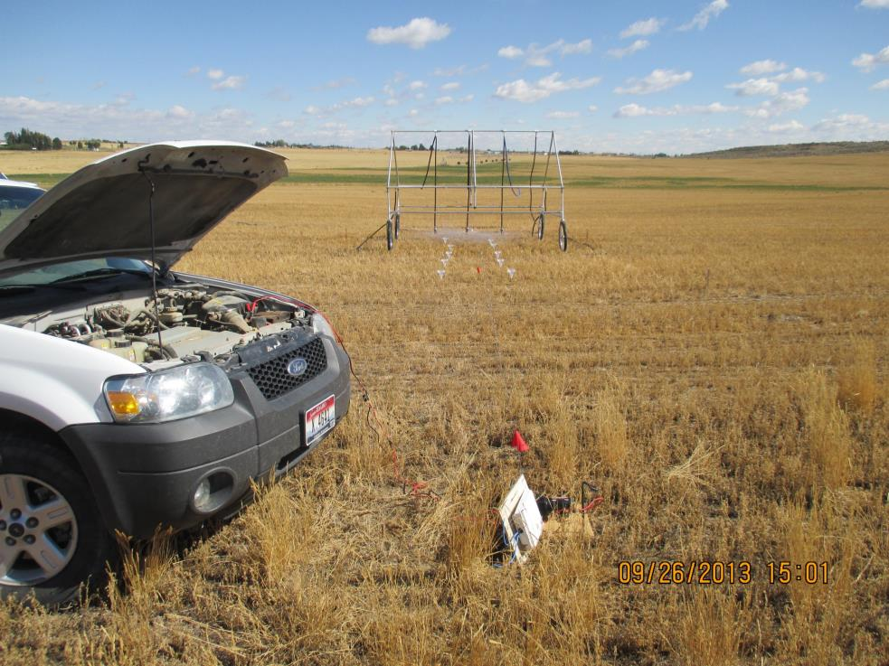

It works! So far, *all* demonstration field owners are expanding its use on their farms.

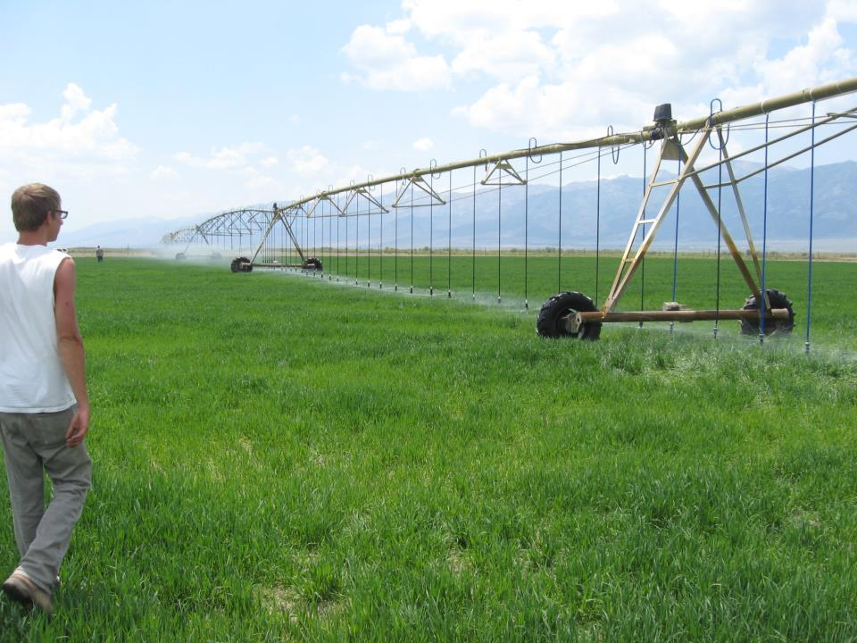

**Overview of LEPA/LESA Challenges**

* **High application rates.** If you have no trouble getting water into the soil, then you might benefit!
  + If you have tight soils and/or steeps slopes, then LEPA/LESA may not be for you.
* **Chemigation**. The sprinklers can go into the canopy. The canopy won’t get wet when this happens.
  + Can raise the drops slightly.
  + Can switch to chemigation spray plate that sprays upwards. This is inexpensive and easy to do.
* **Smaller nozzle sizes**. This may lead to additional plugging if you have dirty water.
  + Finer filter screens may be required.

**Overview of LEPA/LESA Advantages**

* **Irrigation Efficiency** is much higher. You will need less water.
* **Low pressure**! Save pumping energy.
* **Less variation in application efficiency** (less day-night differences in applied depths, less difference between windy vs. calm days.
* **Less lodging.** Drier crops stay more upright.
* **Wheel tracks.** It’s easier to keep them dry.
* **Drier canopy.** Possibly less crop diseases.
* **Maintenance is easier**. No ladders. Stay drier.
* **Better uniformity in corn.**
* **Inexpensive sprinklers (**about $1.82/head vs. $17.06)

**Contact Us for More Information!**

**R. Troy Peters, P.E., Ph.D.**

Extension Irrigation Specialist/Associate Professor

Washington State University, Prosser, WA

509-786-9247. troy_peters@wsu.edu

**Howard Neibling, P.E., Ph.D.**

Extension Water Management Eng./Associate Professor

University of Idaho, Twin Falls, ID

(208) 423-6679. hneiblin@uidaho.edu

**Richard Stroh, P.E.**

Agricultural Energy Specialist

Bonneville Power Administration, Idaho Falls, ID

208-612-3154. rcstroh@bpa